GRAPH
/SCATTERPLOT(MATRIX)=Precipmm ElevationM SlopeDegree TWetnessI BY Bin_inhabited
/MISSING=LISTWISE.

Graph

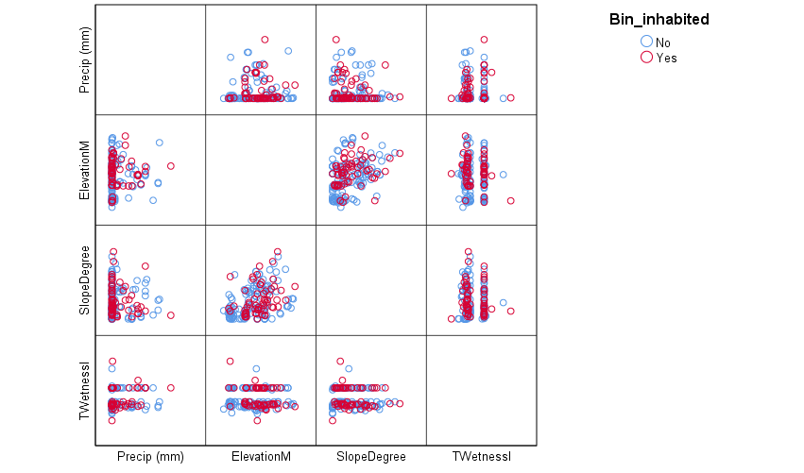

GRAPH
/SCATTERPLOT(MATRIX)=SEEP_DIST INHAB_DIST OUTFALL_DIST IMPERV_DIST BY Bin_inhabited
/MISSING=LISTWISE.

Graph

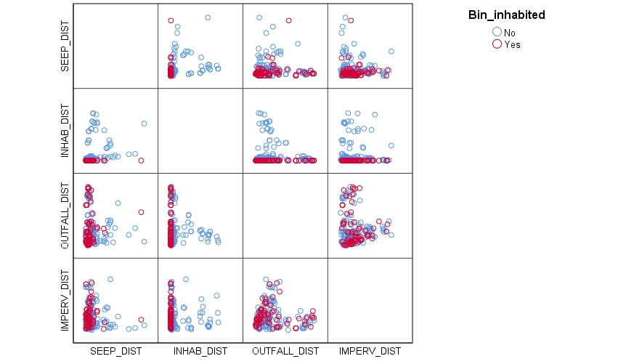

GRAPH
/SCATTERPLOT(MATRIX)=ROAD_DIST TRAIL_DIST BORDER_DIST BY Bin_inhabited
/MISSING=LISTWISE.

Graph

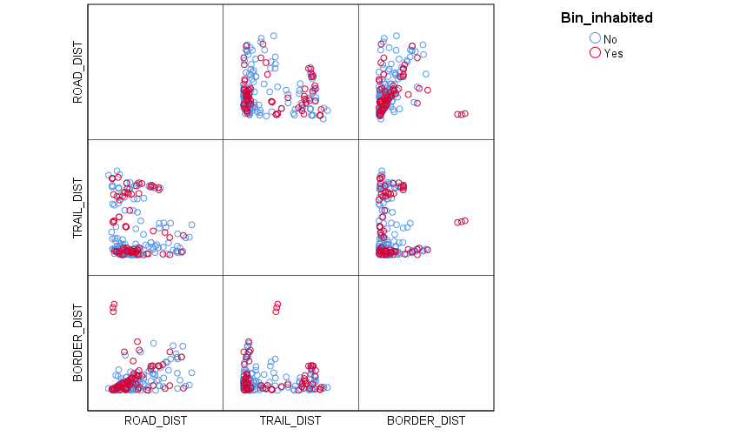

GRAPH
/SCATTERPLOT(MATRIX)=Seeps_per_m2 Seepsperpatch Count_Inhab_inpatch BY Bin_inhabited
/MISSING=LISTWISE.

Graph

